Project Design Phase
Module 3 - Solution Architecture

Date : | 27.09.2026
Team ID : | SWTID-2026-9496
Project Name : | Streamlining IT Procurement: Automating Standard Laptop Orders with Flow Designer
Maximum Marks | 4 Marks

Solution Architecture

Solution architecture bridges the gap between the business problem and the technology solution. For this project, the architecture is designed to:
- Automate the standard laptop procurement process: Automatically process laptop requests from submission through approval and fulfillment.
- Provide a structured request process: Collect standard laptop requirements through a consistent ServiceNow request form.
- Automate approval and task management: Use Flow Designer to route approvals and create procurement tasks automatically.
- Improve visibility and tracking: Maintain request status and workflow activity throughout the procurement lifecycle.

Solution Architecture Diagram
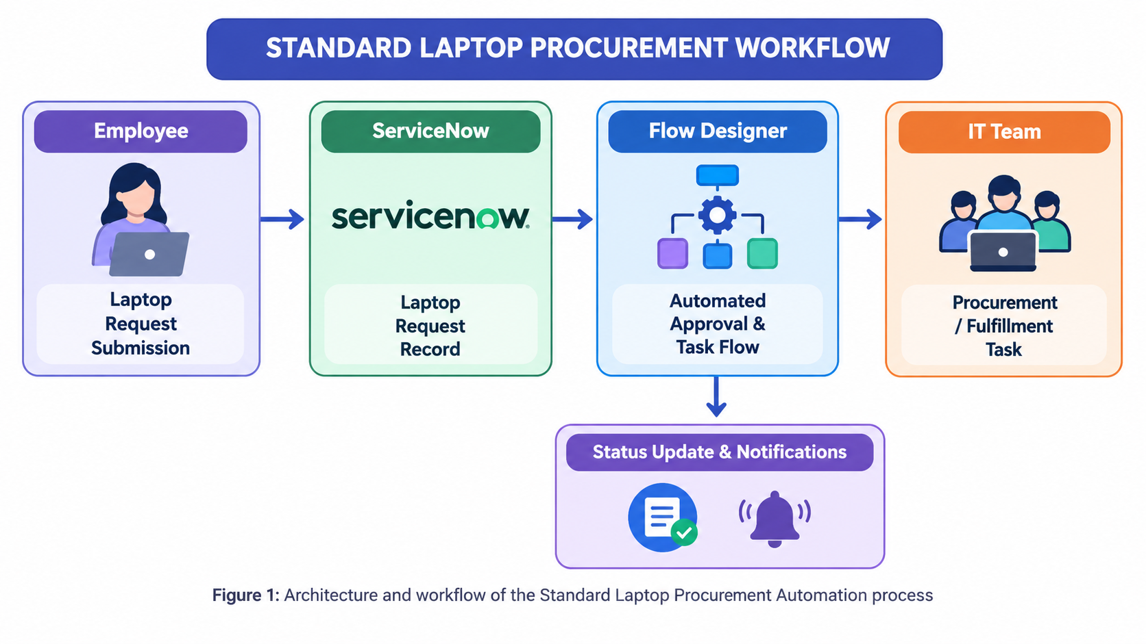

Process Workflow & Technical Specification

1. Request Submission: Employee submits a standard laptop request through the ServiceNow request/catalog interface. Required employee and laptop information is captured.
2. Flow Trigger: Flow Designer detects the newly submitted request. The predefined laptop procurement flow starts automatically.
3. Approval Processing: Flow Designer sends the request to the appropriate approver. The workflow checks the approval result.
4. Procurement Task Creation: If approved, Flow Designer automatically creates a procurement/fulfillment task. The task contains the required laptop request information.
5. Fulfillment & Status Update: IT/procurement team processes the laptop order. The request status is updated as the order progresses.
6. Completion & Notification: Once the laptop is fulfilled, the request is marked as completed. An automated notification is sent to the employee.

